**“Hugo Static Website Generator Workshop”**

**Topic:** “Build & Host Your Personal Blog using Hugo”

**Date:** 30th July, 2025

**Time:** 11:15 am to 1:00 pm

**Venue:** FE Lab, A wing, Don Bosco Institute of Technology, Kurla, Mumbai 400070

**Speaker:** IEEE-DBIT student chapter: Krushnali Mungekar, Shariya Ansari along with Dhruv Tare and Asma Sayed

**Support team:** Alston Coelho, Dhruv Tare, Asma Sayed

**No. of Participants Present:** 25

**No. of Girl Participants Present:** 12

**No. of Boy Participants Present:** 13

**Objective:**

* To introduce students to static site generation using Hugo.
* To provide hands-on experience in creating and deploying blogs using Hugo.
* To demonstrate integration with GitHub Pages for hosting.

**Outcome:**

* Students understood the concept of static website generation.
* Learnt the process of installing Hugo and initializing a project.
* Gained practical experience in customizing content and themes.
* Successfully deployed a Hugo-generated site on GitHub Pages.

**Description:**

IEEE DBIT CS Student Chapter organized a hands-on **“Hugo Static Website Generator Workshop”** on 24th July 2025 for students of all departments.

The session began with an introduction to static site generators and a comparison of Hugo with other tools like Jekyll and Gatsby, highlighting its use cases and industry relevance.

We guided the students step-by-step through the installation of Hugo, starting with downloading the correct version for their OS. They learned how to set up the environment variables and verify the installation using the command line. Finally, we ensured everyone successfully ran their first Hugo command to confirm the setup.

#### ****Workshop Itinerary:****

* **Introduction:**
  + What is Hugo?
  + Comparison with other tools (Jekyll, Gatsby).
  + Use cases & industry relevance.
* **Hands-On: Creating the Blog:**
  + Hugo installation.
  + Project initialization.
  + Folder structure overview.
  + Theme integration.
* **Customizing Content:**
  + Adding posts and pages.
  + Editing config.toml.
  + Markdown basics for blogging.
* **Deployment to GitHub Pages:**
  + Pushing code to GitHub.
  + Setting up GitHub Pages.
  + Final preview.
* **Wrap-up & Showcase:**
  + QnA.
  + Sharing deployed blog links.
  + Feedback form.

This hands-on approach allowed students to create their first Hugo-powered blog from scratch and deploy it online using GitHub Pages within the session.

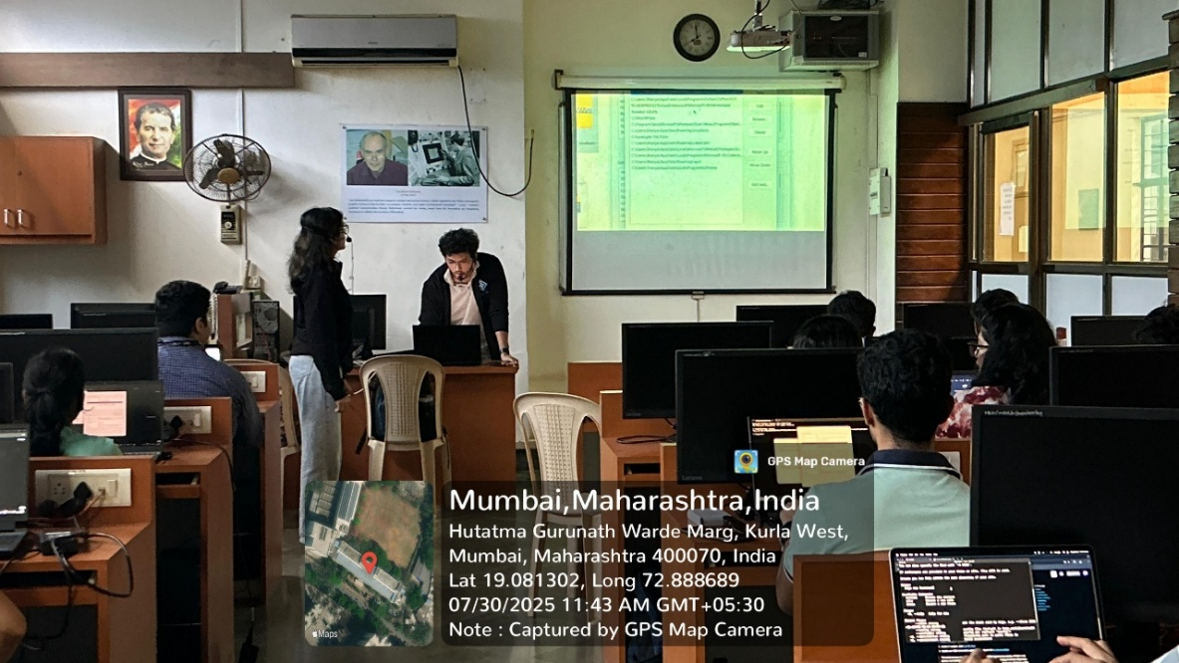**Event Images: -**

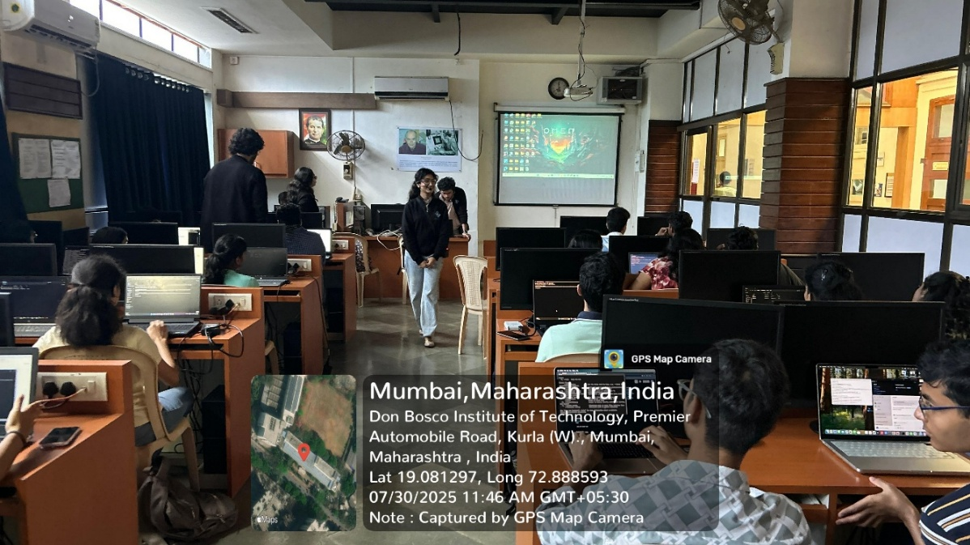

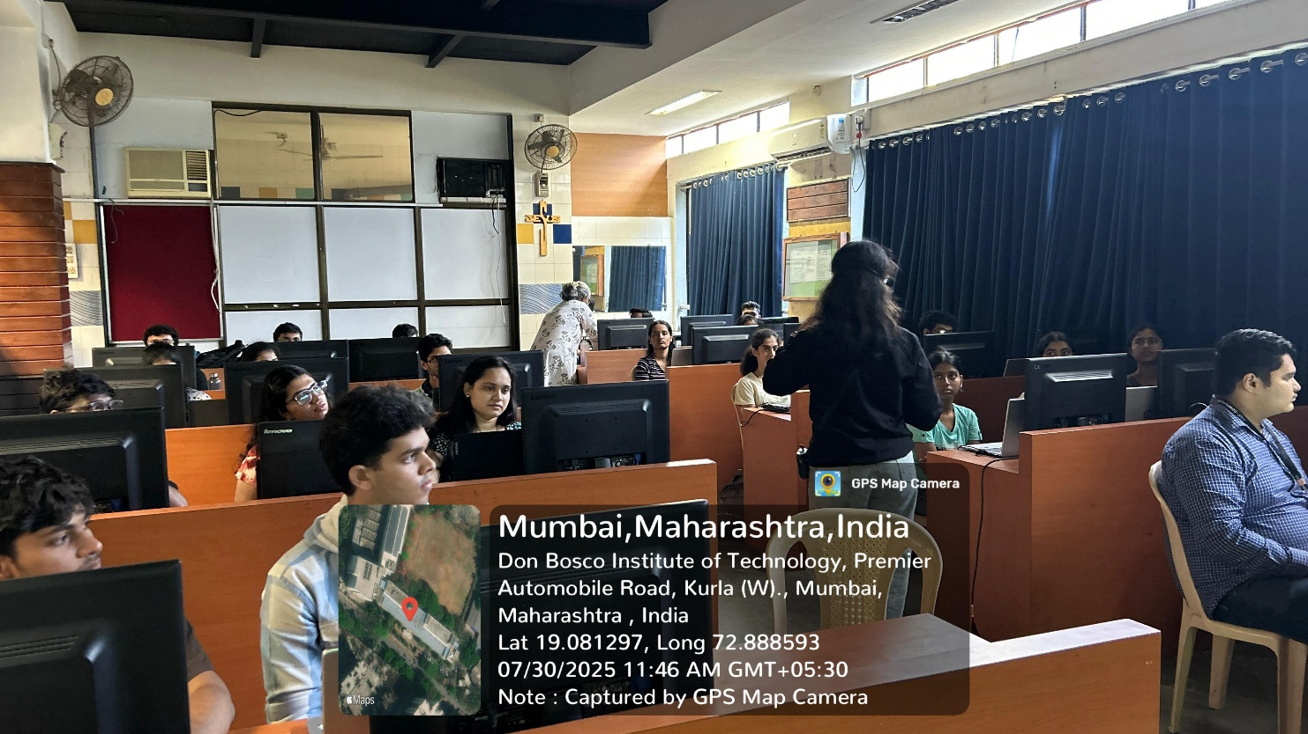

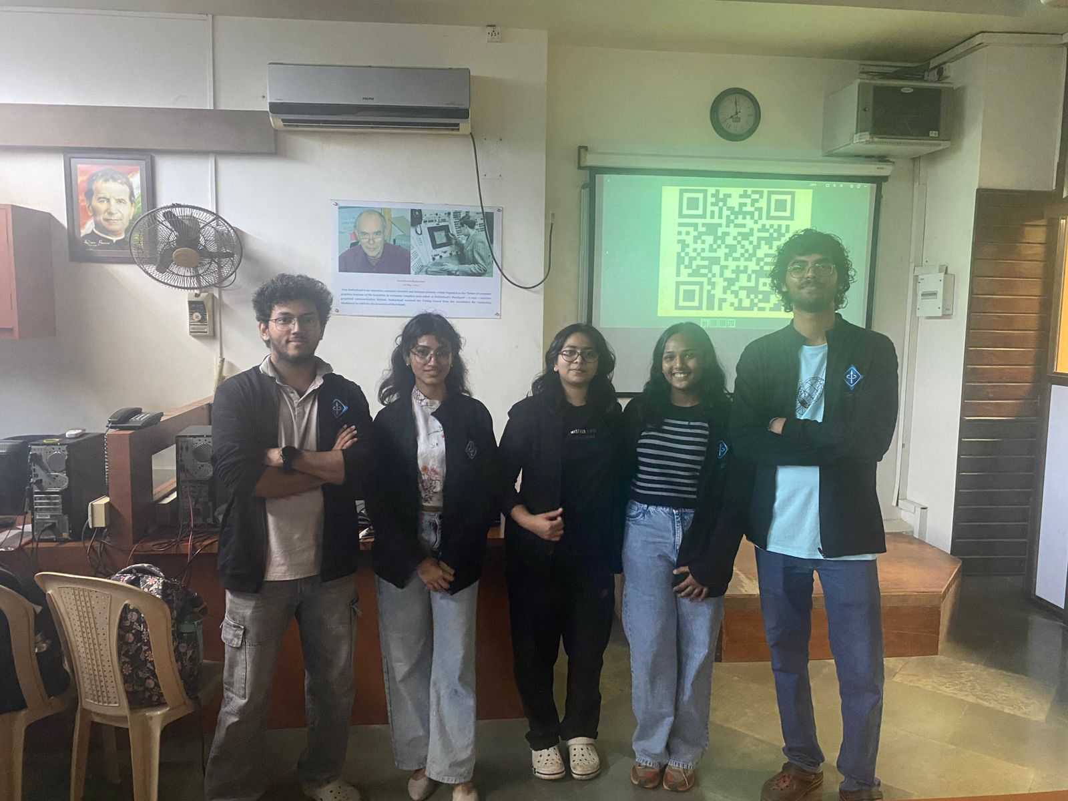

**Event Poster:**

**Social Media Links:**

Instagram - <https://www.instagram.com/ieee_dbit/?hl=en>

Website – https://ieee.dbit.in

**Participants: -**

|  |  |  |  |
| --- | --- | --- | --- |
| **Sr no.** | **Name of the Student** | **Roll no.** | **Department** |
|  | Mrunal Sagvekar | 36 | COMPS |
|  | Tanishka Chadan | 3 | IT |
|  | Vidhisha Mankar | 30 | IT |
|  | Dylan Noronha | 18 | COMPS |
|  | Alister varghese | 3 | COMPS |
|  | Samara Nazerath | 25 | COMPS |
|  | Risa | 53 | COMPS |
|  | Astha Bombale | 1 | IT |
|  | Sampada Kaginkar | 23 | IT |
|  | Newton D'souza | 32 | COMPS |
|  | Om Arolkar | 6 | MECH |
|  | Aradhya Pawar | 1 | COMPS |
|  | Het Visariya | 60 | COMPS |
|  | Atharva Dalvi | 22 | COMPS |
|  | Om Waghmare | 63 | COMPS |
|  | Simone D'sa | 13 | IT |
|  | Elissa Quadros | 29 | COMPS |
|  | Neil Joseph Palissery | 20 | COMPS |
|  | Ananya Pravin Shetty | 54 | IT |
|  | Ivie Santosh Pendse | 44 | IT |
|  | Arya Dharmadhikari | 11 | IT |
|  | Aditya Makarand Sabnis | 35 | COMPS |
|  | Aayush Pulkundwar | 48 | IT |
|  | Asma Sayed | 48 | COMPS |
|  | Jaden | 6 | COMPS |

**Feedback Categories and Average Ratings:**

Departments:

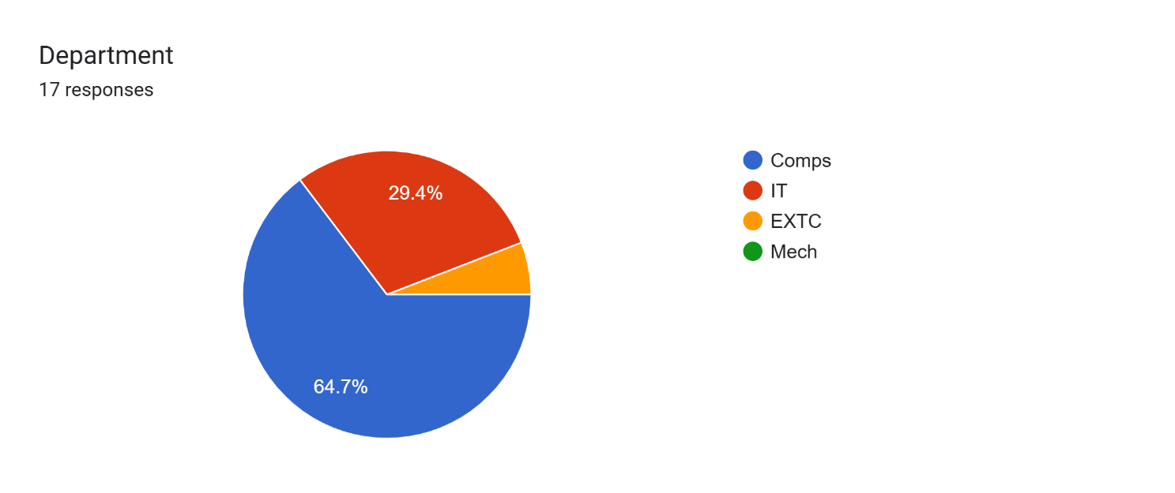

Ratings of the workshop:

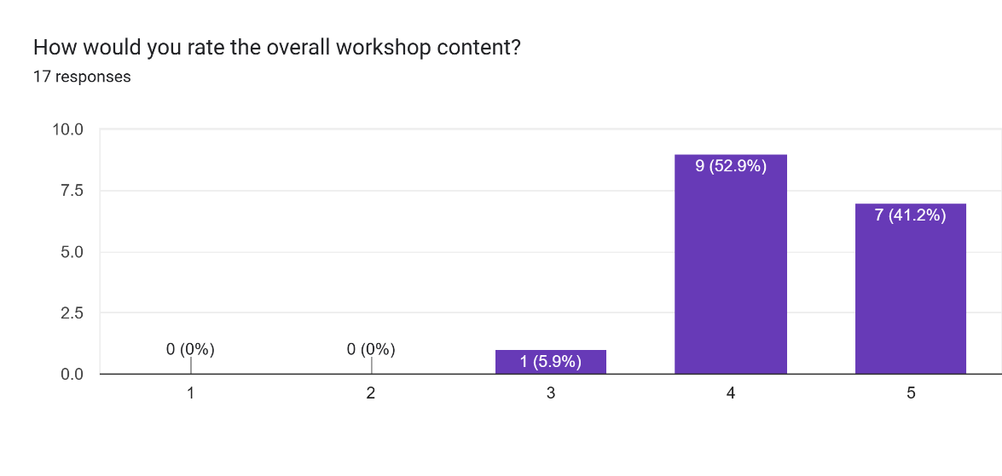

Ratings of the Concept clarity in the Workshop:

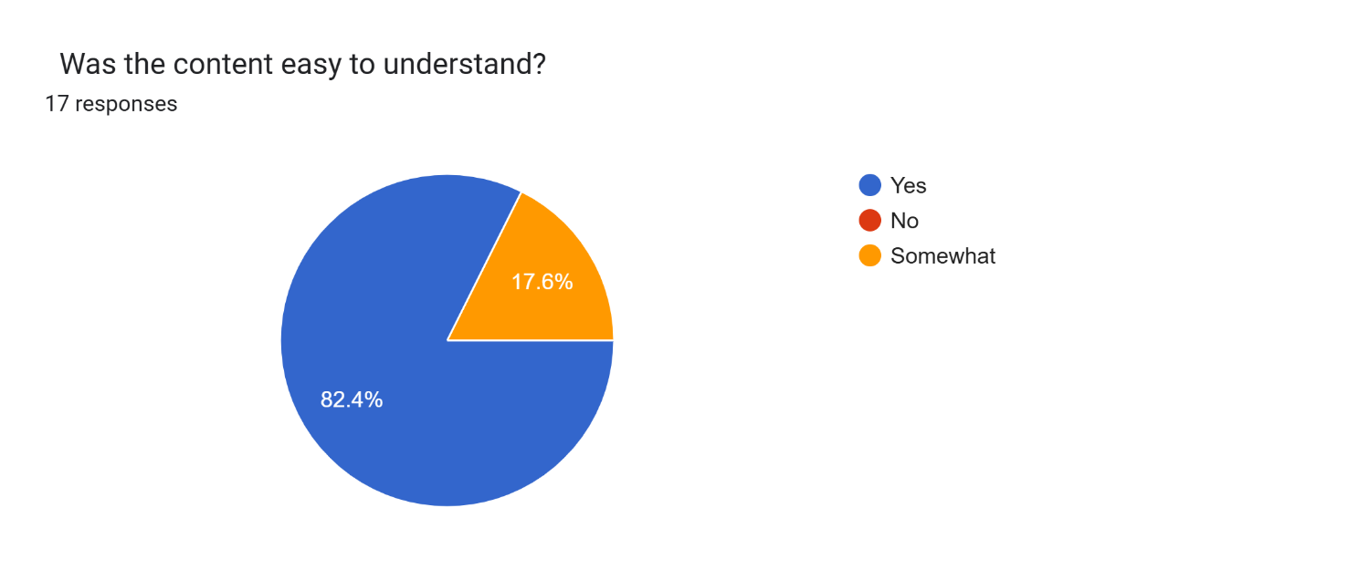

How was the instructor:

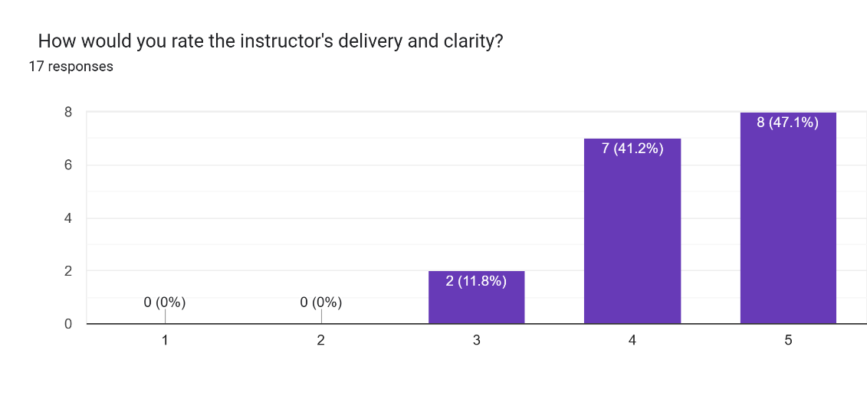

Instructiveness of the Workshop:

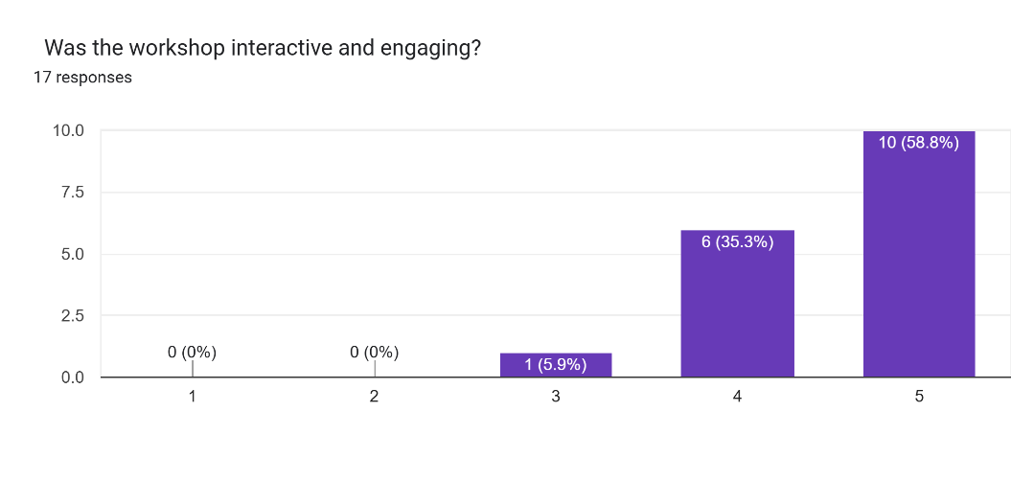

Comments on the workshop: -

Any additional comments or topics you’d like us to cover?

* 1. Java backend or frameworks
  2. More instructors
  3. Theory part clearly understood but executing process needs to clear
  4. Great job

**Conclusion:**

The **Hugo Static Website Generator Workshop** successfully provided participants with both theoretical knowledge and practical skills in building static websites using Hugo. By the end of the session, students were able to set up, customize, and deploy a fully functional blog, giving them valuable insight into modern web development workflows.

**Report Prepared by: IEEE DBIT reporting team**

**Name of the Student: Dhruv Tare**

**Post of the student: Reporting Head**

**Name of the Student: Pritika** **Mediboina**

**Post of the Student: Joint Reporting Head**